Packet Tracer – Skills Integration Challenge - EIGRP

**Note**:This activity and the similar **Packet Tracer - Skills Integration Challenge - OSPF** activity are meant as resources for you to determine what skills you may not have yet mastered from the previous courses. Refer to your notes and previous content if you need assistance. But it may be fun initially to see just how much you retained.

Topology

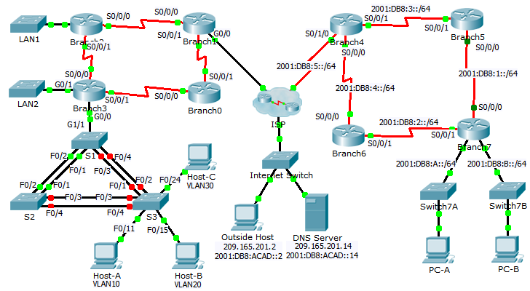

Addressing Table

|  |  |  |  |  |  |
| --- | --- | --- | --- | --- | --- |
| Device | Interface | IP Address | | Subnet Mask | Default Gateway |
| IPv6 Address/Prefix | | |
| Branch0 | S0/0/0 | 192.168.3.241 | | 255.255.255.252 | N/A |
| S0/0/1 | 192.168.3.254 | | 255.255.255.252 | N/A |
| Branch1 | G0/0 | DHCP Assigned | | DHCP Assigned | N/A |
| S0/0/0 | 192.168.3.245 | | 255.255.255.252 | N/A |
| S0/0/1 | 192.168.3.253 | | 255.255.255.252 | N/A |
| Branch2 | G0/0 | 192.168.2.1 | | 255.255.255.0 | N/A |
| S0/0/0 | 192.168.3.246 | | 255.255.255.252 | N/A |
| S0/0/1 | 192.168.3.249 | | 255.255.255.252 | N/A |
| Branch3 | G0/0.10 |  | |  | N/A |
| G0/0.20 |  | |  | N/A |
| G0/0.30 | 192.168.1.193 | | 255.255.255.224 | N/A |
| G0/0.88 | 192.168.1.225 | | 255.255.255.240 | N/A |
| G0/0.99 | 192.168.1.241 | | 255.255.255.252 | N/A |
| G0/1 | 192.168.0.1 | | 255.255.255.0 | N/A |
| S0/0/0 | 192.168.3.250 | | 255.255.255.252 | N/A |
| S0/0/1 | 192.168.3.242 | | 255.255.255.252 | N/A |
| Branch4 | S0/0/0 | 2001:DB8:4::4/64 | | | N/A |
| S0/0/1 | 2001:DB8:3::4/64 | | | N/A |
| S0/1/0 | 2001:DB8:5::4/64 | | | N/A |
| Router ID | 4.4.4.4 | | | N/A |
| Branch5 | S0/0/0 | 2001:DB8:1::5/64 | | | N/A |
| S0/0/1 | 2001:DB8:3::5/64 | | | N/A |
| Link-local | FE80::5 | | | N/A |
| Router ID | 5.5.5.5 | | | N/A |
| Branch6 | S0/0/0 | 2001:DB8:4::6/64 | | | N/A |
| S0/0/1 | 2001:DB8:2::6/64 | | | N/A |
| Link-local | FE80::6 | | | N/A |
| Router ID | 6.6.6.6 | | | N/A |
| Branch7 | G0/0 | 2001:DB8:7:A::1/64 | | | N/A |
| G0/1 | 2001:DB8:7:B::1/64 | | | N/A |
| S0/0/0 | 2001:DB8:1::7/64 | | | N/A |
| S0/0/1 | 2001:DB8:2::7/64 | | | N/A |
| Link-Local | FE80::7 | | | N/A |
| Router ID | 7.7.7.7 | | | N/A |
| ISP | G0/0 | 209.165.202.129 | 255.255.255.224 | | N/A |
| S1 | VLAN 88 | 192.168.1.226 | 255.255.255.240 | | 192.168.1.225 |
| S2 | VLAN 88 | 192.168.1.227 | 255.255.255.240 | | 192.168.1.225 |
| S3 | VLAN 88 | 192.168.1.228 | 255.255.255.240 | | 192.168.1.225 |
| Host-A | NIC | DHCP assigned | DHCP assigned | | DHCP assigned |
| Host-B | NIC |  |  | |  |
| Host-C | NIC | 192.168.1.194 | 255.255.255.224 | | 192.168.1.193 |
| PC-A | NIC | 2001:DB8:7:A::A/64 | | | FE80::7 |
| PC-B | NIC | 2001:DB8:7:B::B/64 | | | FE80::7 |

1. VLAN and Port Assignments Table

|  |  |  |
| --- | --- | --- |
| VLAN | Name | Interface |
| 10 | Students | F0/5-11 |
| 20 | Faculty/Staff | F0/12-17, G1/1-2 |
| 30 | Guest(Default) | F0/18-24 |
| 88 | Management | N/A |
| 99 | Native | F0/1-4 |

1. Scenario

You are a network technician new to a company that has lost its last technician in the middle of a system upgrade. You are tasked with completing upgrades to the network infrastructure that has two locations. Half of the enterprise network uses IPv4 addressing and the other half uses IPv6 addressing. The requirements also include a variety of routing and switching technologies.

1. Requirements

You have console access to **Branch3**, **Branch7**, and **S3**. You can remotely access other devices with the username **admin** and password **adminpass**. The password for accessing privileged EXEC mode is **class**.

IPv4 Addressing

* Finish designing the IPv4 addressing scheme. Subnets already assigned are using the 192.168.1.0/24 address space. Use the remaining space to meet the following criteria:
  1. 120 hosts for the **Student** VLAN attached to the **Branch3** G0/0.10 interface.
  2. 60 hosts for the **Faculty/Staff** VLAN attached to the **Branch3** G0/0.20 interface.
* Configure inter-VLAN routing and assign the first available address from each subnet to subinterfaces on the **Branch3** router.
* Assign the second available address in the Faculty/Staff VLAN to Host-B.

IPv4 Routing

* Configure EIGRP for IPv4 on **Branch3**.
  1. Enable EIGRP 22.
  2. Advertise each of the directly connected networks and disable automatic summarization.
  3. Prevent routing updates from being sent out the LAN interfaces.
  4. Configure a summary route for the **Branch3** LANs and advertise the route to **Branch1** and **Branch2**.
* Configure a directly connected default route on **Branch1** pointing to the ISP and propagate it within the EIGRP updates.

DHCP

* Configure **Branch3** to act as a DHCP server for VLAN 10 on **S3**.
  1. The case-sensitive pool name is **Students**.
  2. The DNS server is 209.165.201.14.
  3. Exclude the first 10 addresses from the pool.
* Configure **Branch1** to receive an IPv4 address from the **ISP**.

IPv6 Routing

* Configure EIGRP for IPv6 on **Branch7**.
  1. Enable IPv6 routing and EIGRP for IPv6 using ASN 222.
  2. Assign router ID 7.7.7.7.
  3. Advertise directly connected networks.
  4. Configure IPv6 summary routes for the LANs and advertise them to directly connected routers.
* Configure a fully specified default route on **Branch4** pointing to the ISP and propagate it within the EIGRP updates.

Basic Switch Security

* Configure **S3** with the following security settings.
  1. Banner MOTD that includes the word **warning**.
  2. Console port login and password of **cisco**.
  3. Encrypted enable password of **class**.
  4. Encrypt plain text passwords.
  5. Shut down all unused ports.
* Enable port security on **S3** on the interfaces that the PCs are connected to.
  1. Configure as access ports.
  2. Only allow 1 host per port.
  3. Enable dynamic learning that stores the MAC address in the running configuration.
  4. Ensure that port violations disable ports.
  5. Configure PortFast and BPDU Guard.

VLAN

* Create and name the VLANs on **S3** based on the **VLAN Table**.
* Assign the switch ports on **S3** to VLANs according to the **VLAN** **Table**.
* Configure the connection between **Branch3** and **S1** as a trunk and assign it to VLAN 99.

Spanning Tree

* Configure **S3** to use RSTP as the STP mode.
* Assign **S3** as the root bridge and **S1** as the backup root bridge for VLANs 10 and 20.
* Assign **S1** as the root bridge and **S3** as the backup root bridge for VLANs 30.

Trunking and EtherChannel

* Set **S3** interfaces connected to **S1** and **S2** as trunks and assign the native VLAN.
* Configure EtherChannel on **S3** as desirable.
  1. Use channel group 2 for trunks to **S2**.
  2. Use channel group 3 for trunks to **S1**.
  3. Assign the native VLAN.

Connectivity

* All inside devices should be able to ping the outside host.